1. Write a script called mycase, using the case utility to checks the type of character entered by a user:
   1. Upper Case.
   2. Lower Case.
   3. Number.
   4. nothing

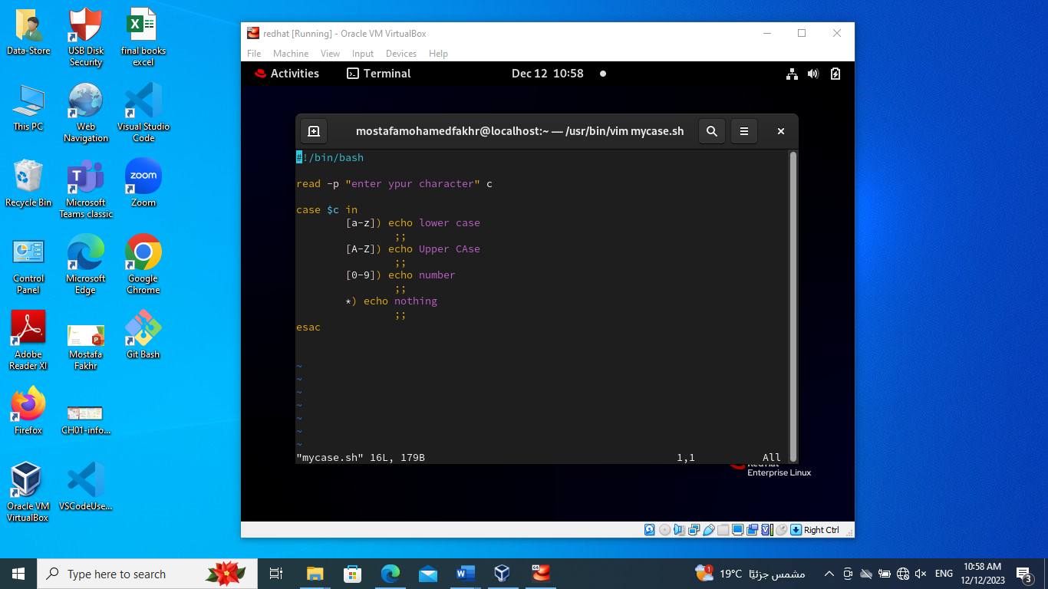 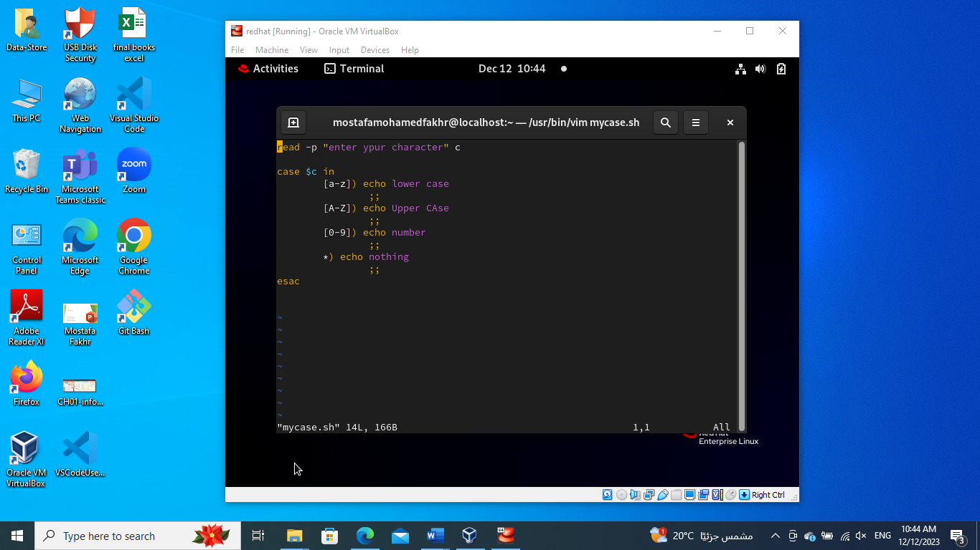

1. Enhanced the previous script, by checking the type of string entered by a user:
   1. Upper Cases.
   2. Lower Cases.
   3. Numbers.
   4. Mix.
   5. Nothing.

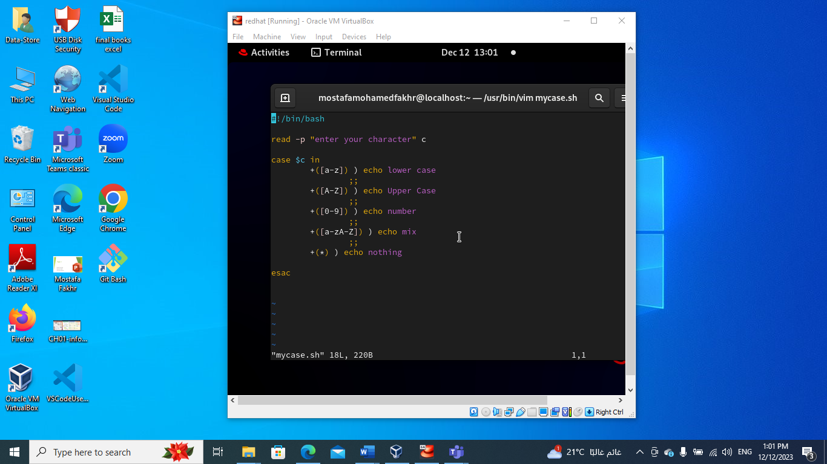

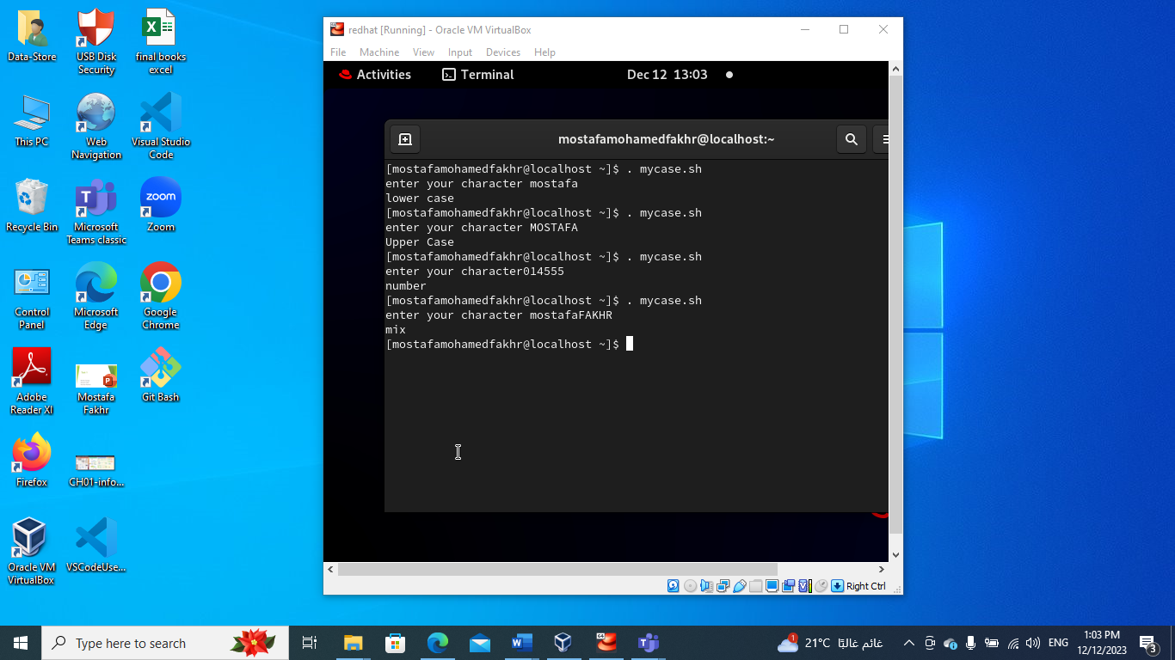

1. Write a script called mychmod using for utility to give execute permission to all files and directories in your home directory.

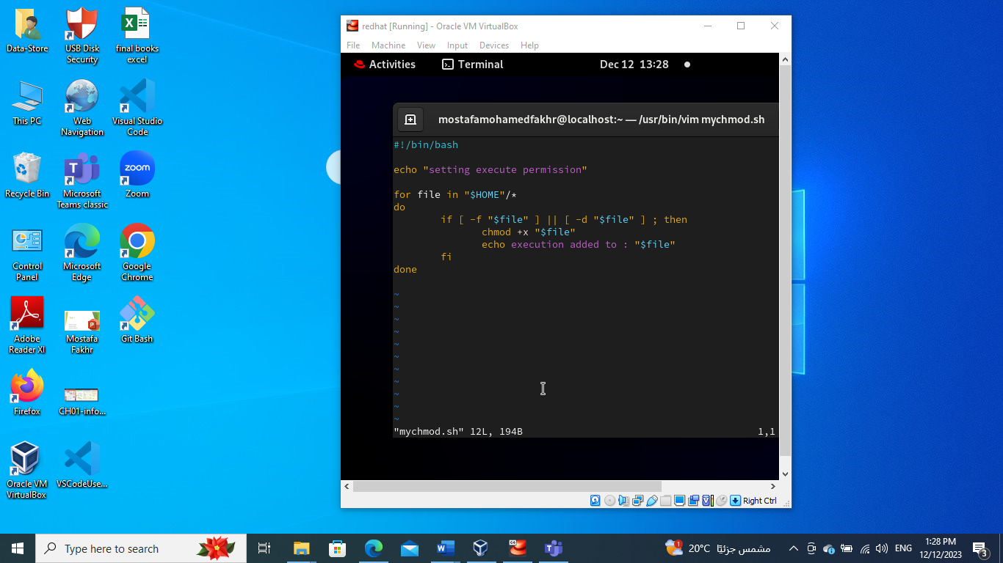

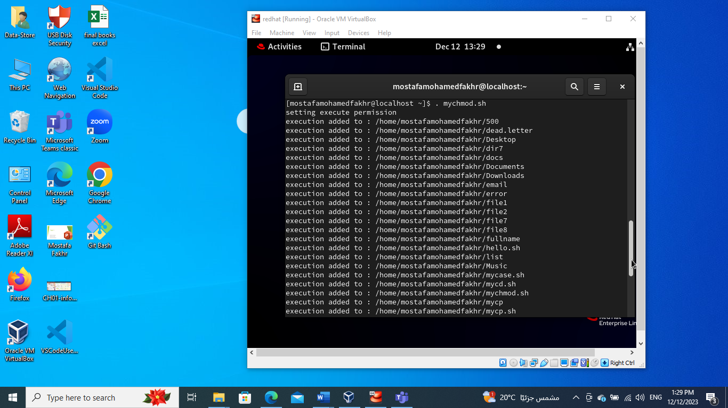

1. Write a script called mybackup using for utility to create a backup of only files in your home directory.

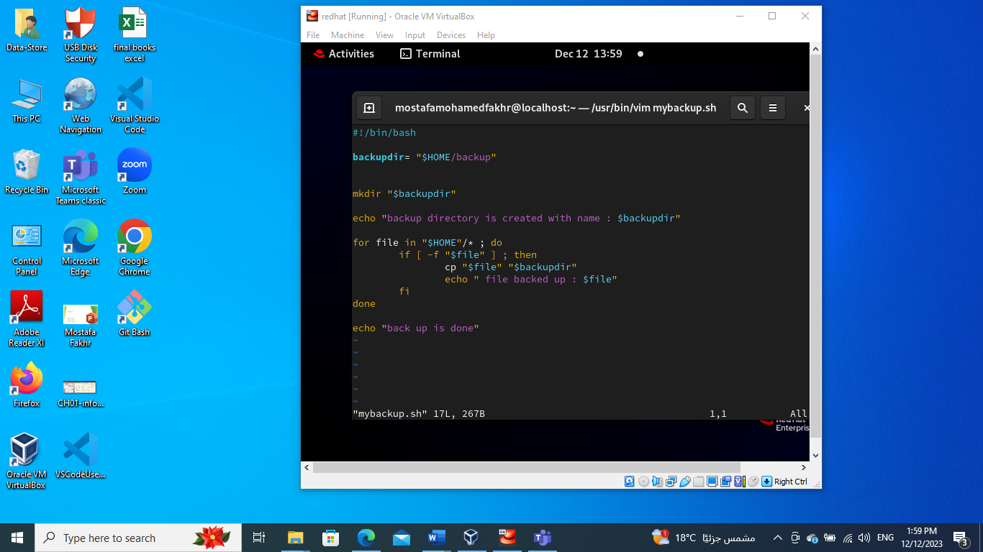

1. Write a script called mymail using for utility to send a mail to all users in the system. Note: write the mail body in a file called mtemplate.

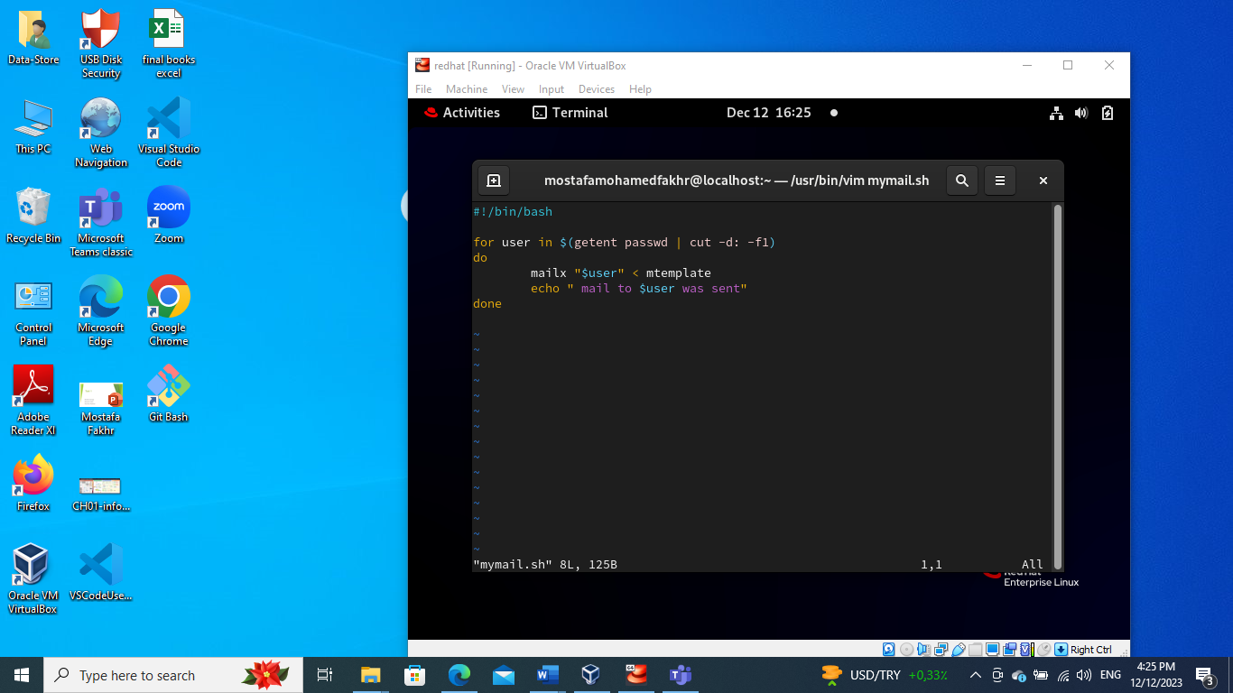

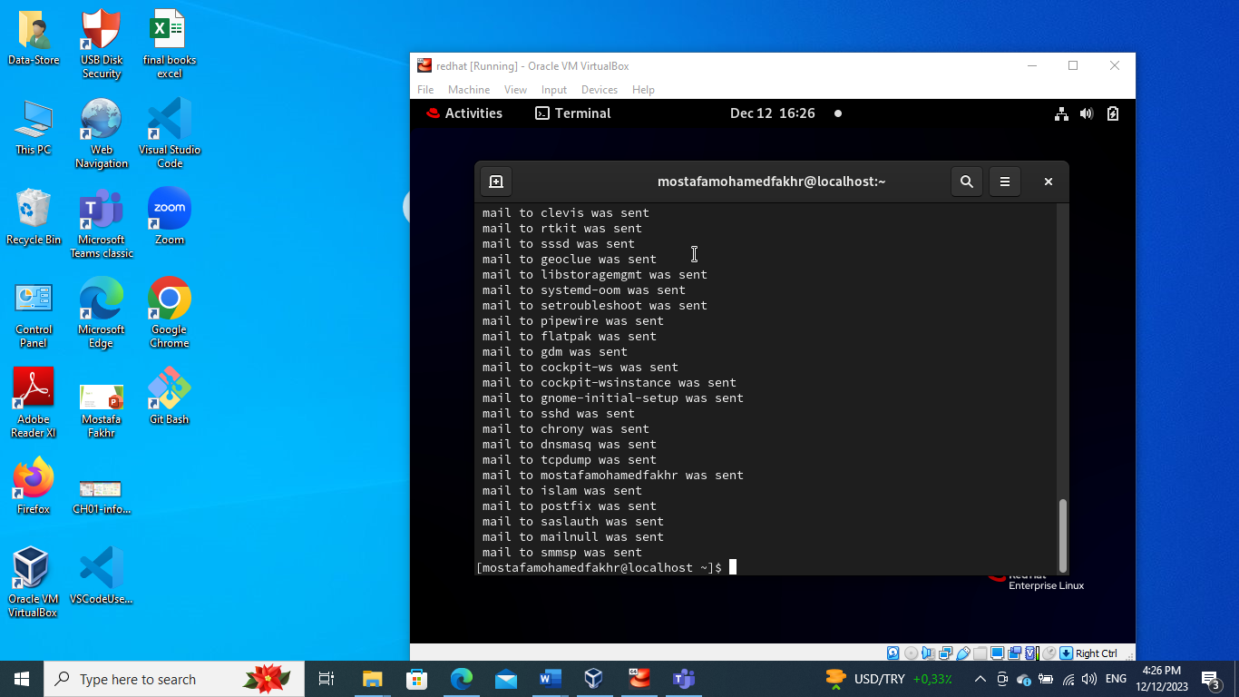

1. Write a script called chkmail to check for new mails every 10 seconds. Note: mails are saved in /var/mail/username.

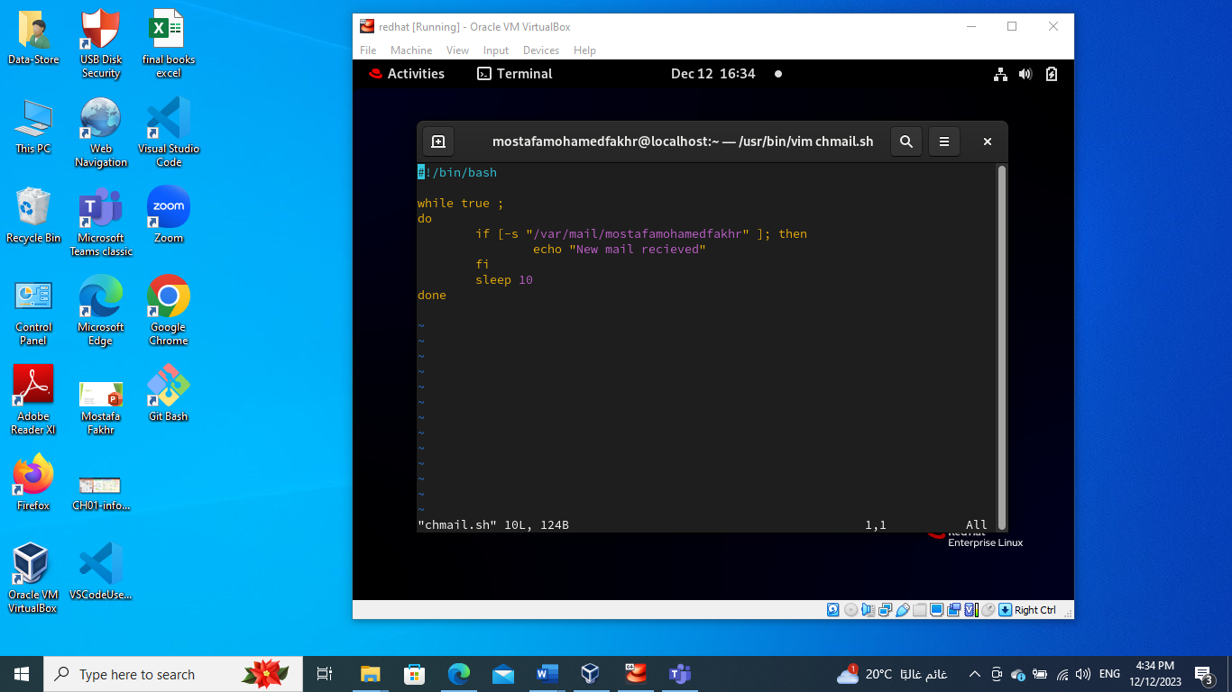

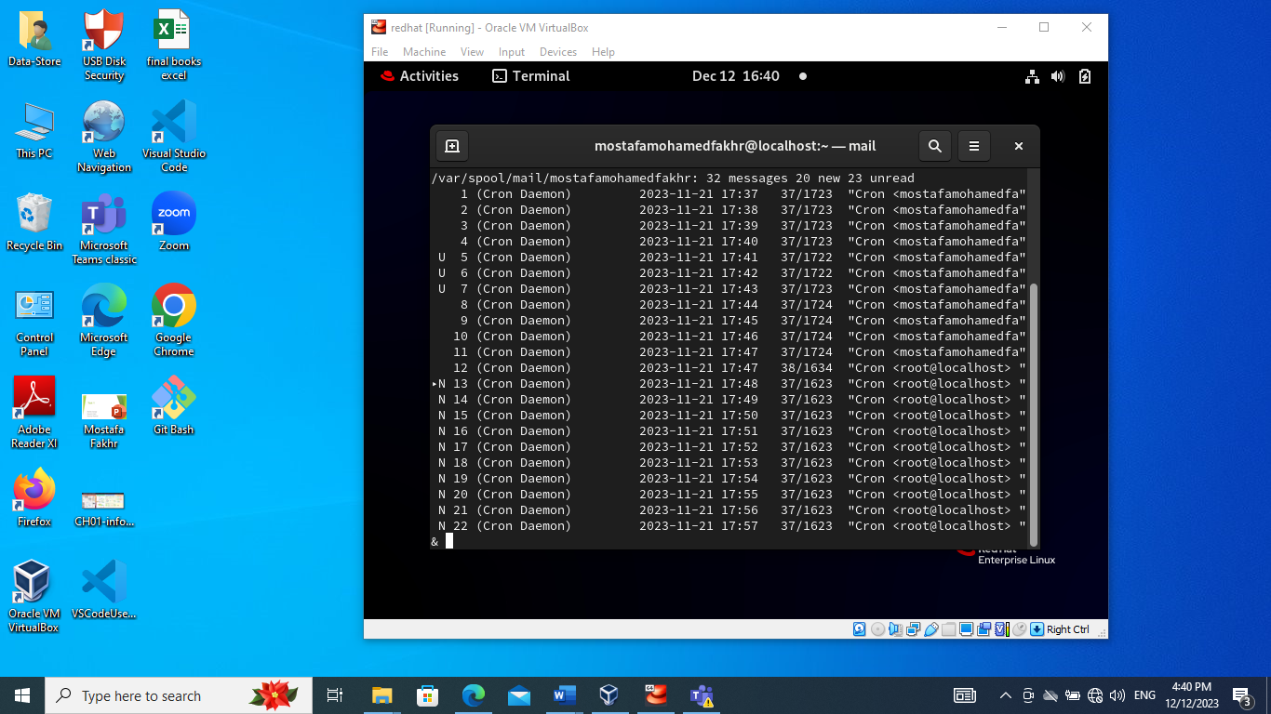

1. What is the output of the following script

typeset –i n1

typeset –i n2

n1=1

n2=1

while test $n1 –eq $n2

do

n2=$n2+1

print $n1

if [ $n1 –gt $n2 ]

then

break

else

continue

fi

n1=$n1+1

print $n2

done

**Output** 🡪 1 as it printed n1 only and skipped the else due to the continue.

1. Create the following menu:
   1. Press 1 to ls
   2. Press 2 to ls –a
   3. Press 3 to exit

Using select utility then while utility.

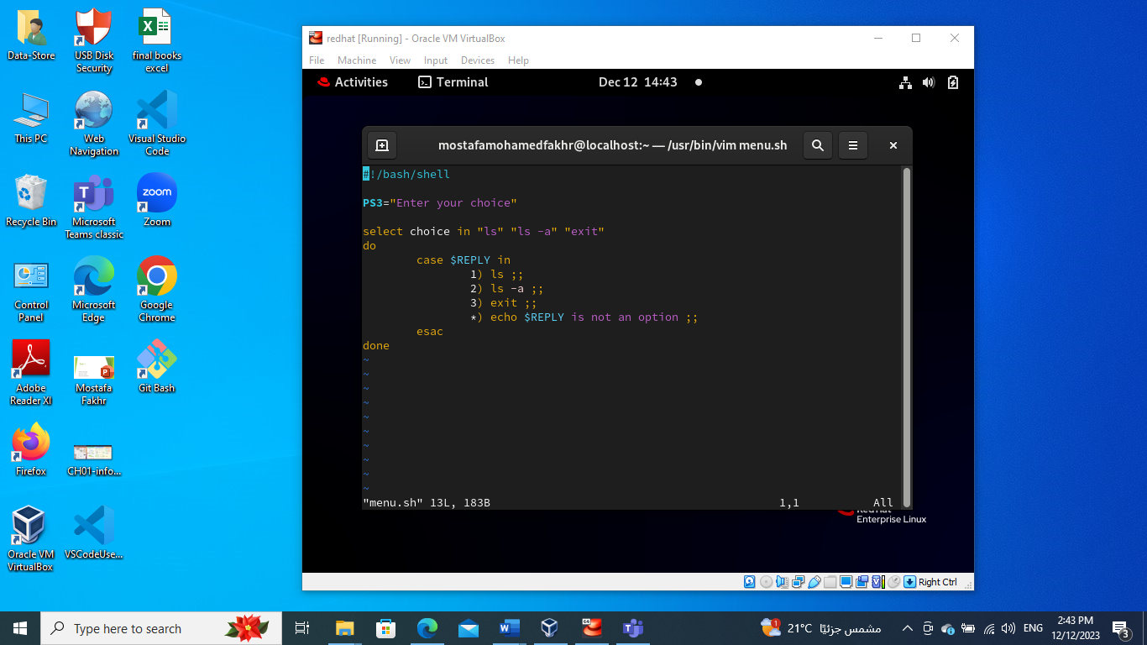

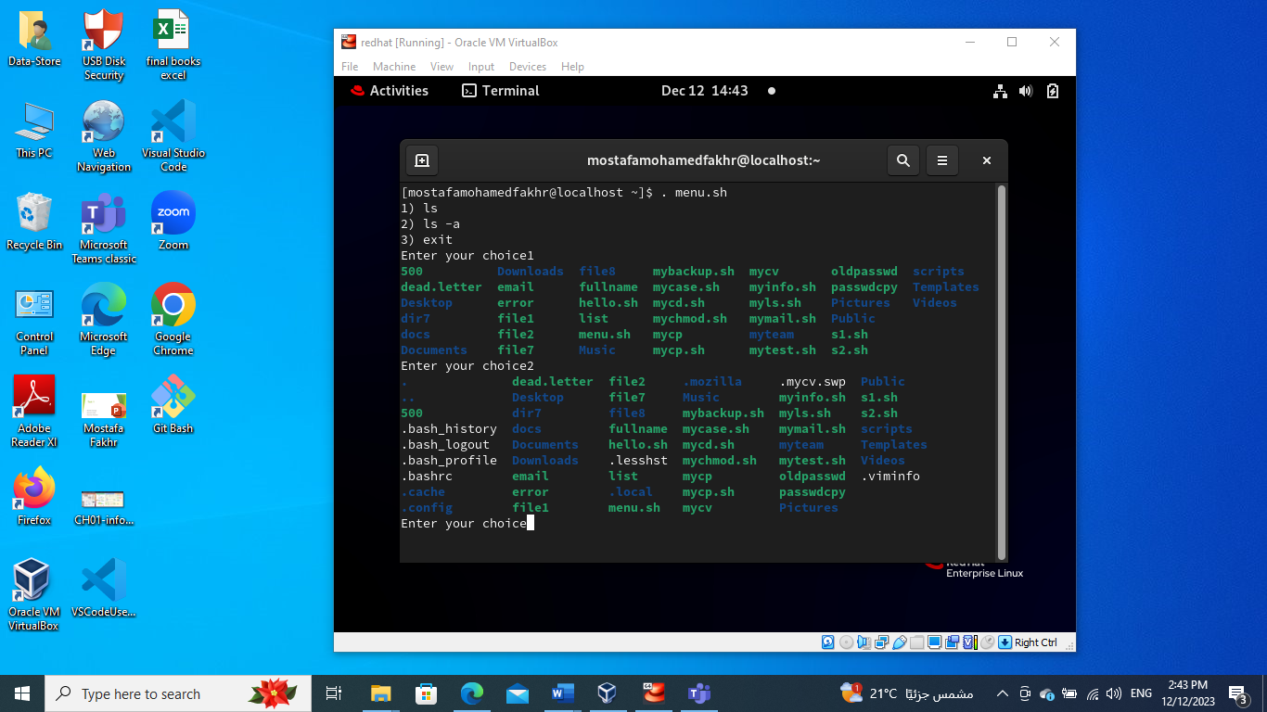

1. Write a script called myarr that ask a user how many elements he wants to enter in an array, fill the array and then print it.

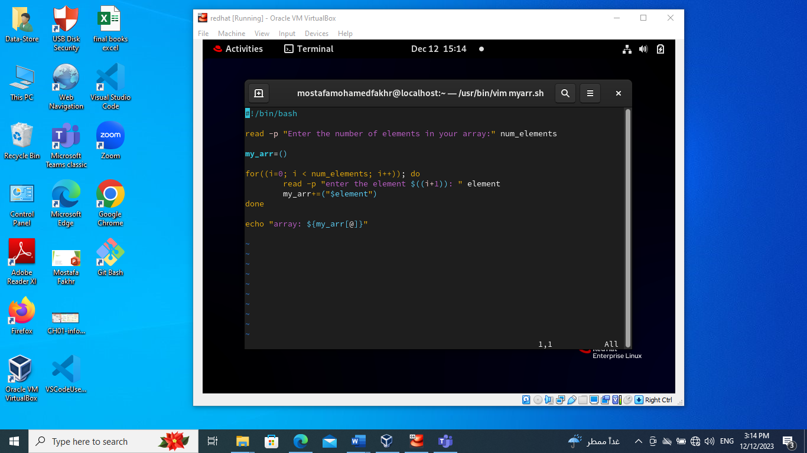

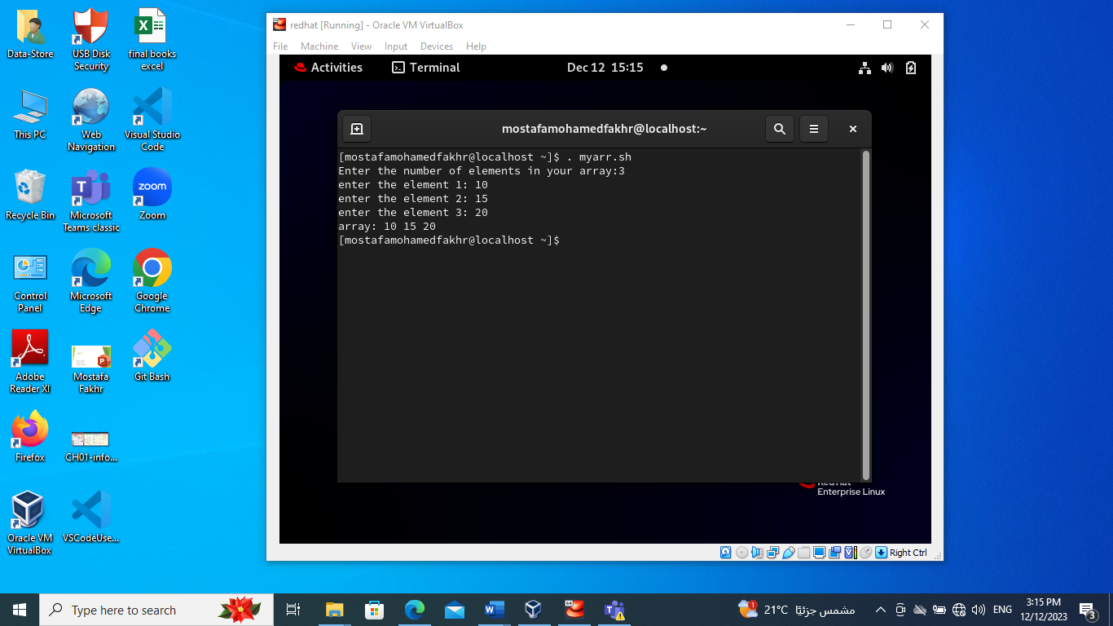

1. Write a script called myavg that calculate average of all numbers entered by a user. Note: use arrays

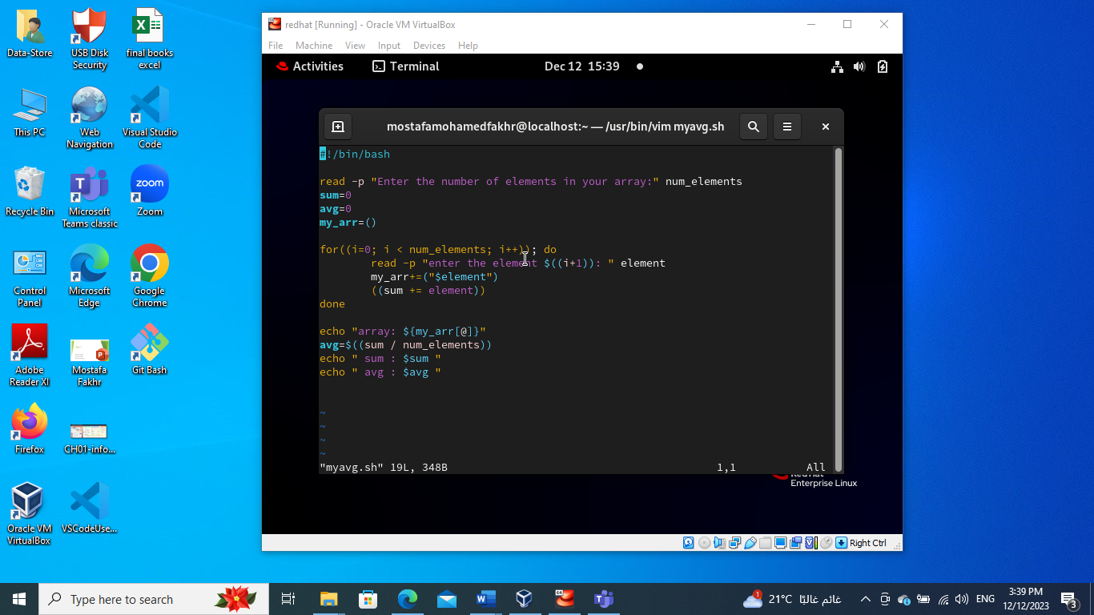

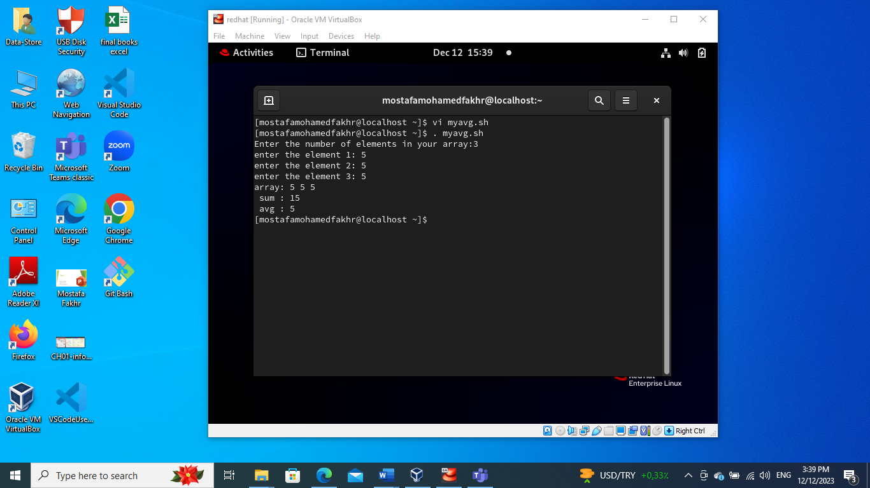

1. Write a function called mysq that calculate square if its argument.

